 | Learning Objective | Teaching / Learning Activity | Resources | Differentiation |  | ECM  &  Citizenship | Homework  &  Assessments | Points to note
Lesson 1 | Enquiry Question: What is tourism and why is it important?
Lesson 1 | LO: To understand the different forms that tourism can take and why tourism is so important.  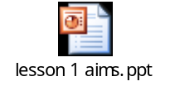 | Starter:  Tourism or not? Go through PP images. Students classify.  Main:  Students complete appropriate task sheet using common ‘Lesson 1 resource sheet’. The data provided looks at the scale and significance of the global tourism industry.  Plenary:  Why do countries invest so heavily in their tourism marketing campaigns? Discuss.  Students watch the Tourism Australia ‘Nothing like Australia’ TV commercial. http://www.youtube.com/watch?v=bvH4vSeGz4I | PPT presentation to lead through the lesson:  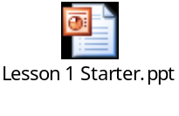  Lesson 1 Resource sheet    Differentiated Task Sheet  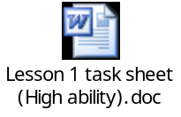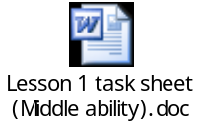 | Two versions of main activity worksheet.  Extension activity in resource sheet. |  | Independent Enquirers | 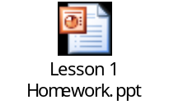 | Mathematics: pupils interpret data and draw conclusions.
Lesson  2 | Enquiry Question: Why has the tourism industry grown so rapidly?
Lesson  2 | LO: To be familiar with the range of factors that have led to  the rapid growth of the tourism industry.  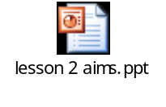 | Starter:  Starter activity on slide 1 of the powerpoint, looking at reasons why people visit different places.  Main:  Work through the PowerPoint, playing short video clip and working through interactive slides.  Cut, sort and paste/write activity. Students will require statements and task sheet. The PowerPoint contains instructions.  Plenary:  Re-cap - look at the photos. Identify the factor shown that has contributed towards the growth of the tourism industry (embedded within last slide of PowerPoint) |     Optional printed sheet (instructions also on PPT):   | Extension activity found on slide 7.  Slides 4 & 5 need to be printed out for less able students.  The instructions to the task may also be printed out. |  | Independent Enquirers | Interview task – instructions on the last slide of the PowerPoint. | Graph reading skills
Lesson  3 | Enquiry Question: What are Britons holiday habits and how have they changed?
Lesson  3 | LO: To draw and interpret data/maps/diagrams to identify how Britons holiday habits are changing and draw conclusions about the size of the UK tourism industry.  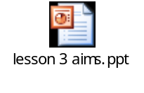 | Starter:  Ten most popular tourist destinations activity (on the first page of the Powerpoint)  Main:  Using the data resources on page 107 Geog 3 or the data resources sheet in case books aren’t available students complete the task sheets and graph outline (graph uses data table B).  The PowerPoint contains all the necessary instructions for this task, but you may wish to print off the instruction sheets too.  Plenary:  Interpretation of a cartoon showing the deterioration of behaviour of Brits abroad over the years. Cartoon and instructions are on the PowerPoint. | 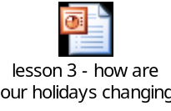      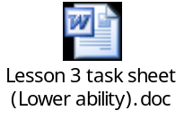   | Two versions of main activity task sheet.  Extension task on the sheet. |  | Independent enquirers | Homework sheet with two questions about Brits abroad and choices of holiday:  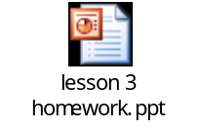 | Maths: pupils interpret data and draw conclusions.
Lessons  4&5 | Enquiry Question: What is the impact of tourism on a British seaside resort?
Lessons  4&5 | LO: To describe the growth of Blackpool as a tourist resort and explain and give reasons for the challenges it has faced in recent years.  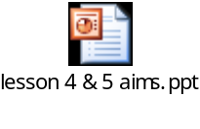 | Starter:  Tourism spellings on page 1 of the PPT.  Main:  Show the Blackpool PPT presentation. Students should annotate the handout at slide 14.  Use the PPT as a basis for completing a Butler’s Model for Blackpool. Students need to add statements to show how Blackpool has evolved over time.  Show the Blackpool video and answer the questions on the sheet. Teachers may want to edit out bits of this video. It was shown before the watershed and it innocent enough, but it does contain references to young peoples’ ‘activities beneath the pier’!!  Plenary:  Play the whole J’aime la Tour video: http://www.youtube.com/watch?v=6xgxkxqqUH0&feature=related  Who would have guessed it was Blackpool? | 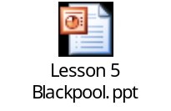  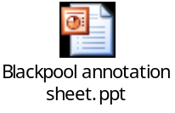  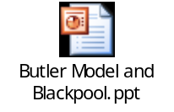    OPTIONAL ACTIVITY: http://www.youtube.com/watch?v=22awn1cLMlg The Apprentice, rebranding Margate. This needs watching through and some additional planning first!!! | Extension: Students to create a plan of ‘recovery’ for Blackpool. They must state how the resort can pull itself out of decline. | Independent Enquirers |  | Use a holiday photo from your family holidays to show where a British resort of your choice lies on the Butler Model.
Lesson  6 (this lesson could take longer than an hour!!!) | Enquiry Question: Tourism in National Parks
Lesson  6 (this lesson could take longer than an hour!!!) | LO: To appreciate why National Parks were set up, why they are of national importance and what conflicts exist there.  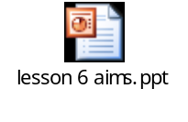 | Starter: Description task using images from Exmoor, the Lake District and Snowdonia (on slide 1 of the PPT).  Main:  Work through the Boardworks PPT completing the interactive exercises. This PPT has been updated to show current information about National Parks. After slide 19 show the Countryfile clip ‘footpath erosion in the Lakes’.  After slide 25, show the Countryfile clip ‘repairing paths in the Lakes’.  Plenary: Complete the quiz on slide 26 of the PPT. PLEASE NOTE: There is an error on this slide because the PPT has been updated. The T at the top of the screen is for twelve, but there are now thirteen National Parks. Students will get this wrong if they answer correctly, so be careful!!! | BOARDWORKS KS3 NATIONAL PARKS PPT  + Countryfile clip ‘footpath erosion in the Lakes’  + Countryfile clips ‘repairing paths in the Lakes’ | Slides 5, 10 and 20 should be printed off to SEN students.  As an extension, G&T students could be asked to plan strategies for resolving conflict in the Lake District. |  | Independent Enquirers. | Homework task looking at conflict on Exmoor:  
Lesson  7 | Enquiry Question: What is the impact of tourism in Ibiza?
Lesson  7 | LO: Students to understand that Ibiza caters for a variety of markets and that some conflicts have led to bad publicity for the island.  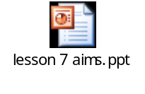 | Starter: Ibiza photo interpretation to challenge perceptions (slide 1 of PPT)  Main: Work through the PPT. There is a map annotation exercise, 3 short video clips (hyperlinked from ppt) and a spider diagram plenary activity. All of these can be used alongside a student handout.  Plenary: Students to create a spider diagram to show solutions to the problems found in Ibiza (final slide of PPT) | 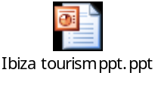   | SEN – enlarged map:  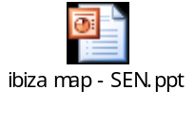  G&T – students to link Ibiza to the Butler Model studied in lessons 4 & 5.
Lesson  8 | Enquiry Question: Tourism in Kenya
Lesson  8 | LO: Students to understand the reasons why Safaris are a popular holiday and also the effect that they have on the countries that provide them.  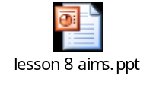 | Starter: Students to note down the 10 most visited places in Africa for a Safari. The teacher can project the answers onto the board.  Main: Work through the Boardworks PPT International Tourism, which focuses on Safaris in Kenya. There are many interactive activities and a student handout to accompany them if required.  Plenary: Anagrams quiz on slide 23. This activity is timed and students can request clues to be given. | 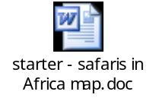  Use alongside Folens Geog@work3 resources  BOARDWORKS KS3 INTERNATIONAL TOURISM PPT | SEN – handouts can be printed to accompany the lesson.  G&T – extension activity. Students can look at the rules for the Masai Mara park and either justify them or rank them in order of importance:  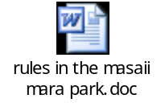 |  | Independent Enquirers. | Problems with Safaris homework sheet:  TAKEN FROM FOLENS GEOG@WORK 3 BOOK | Please note that Masai Mara can be spelt in several ways. Therefore it may appear in different formats throughout this lesson.
Lesson  9 | Enquiry Question: Ecotourism
Lesson  9 | LO: Students to understand the concepts behind ecotourism. They will consider key objectives and different viewpoints.  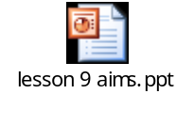 | Starter: Students to assess impact of tourists upon an area, using slide 1 of the PPT.  Main: Work through the PPT, using the handout, scissors and glue to attempt each task set.  Plenary: Pollster to gauge opinion. The class should vote on whether the mega resort at the Gulf of Papagoya (discussed during the PPT) should go ahead or not. | ALL RESOURCES ADAPTED FROM BOARDWORKS MYWORKS ECOTOURISM QUIZ  Pollster stored on shared drive. | The resources for the lesson can be enlarged for SEN students.  This lesson is scaffolded to support all learners. |  | Independent Enquirers | Elephant Ecotourism rules task:  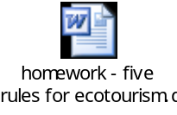
Lesson  10 + 11 | Enquiry Question: How would you develop tourism?
Lesson  10 + 11 | LO: To assess students knowledge of the tourism module. | Students are given a map on which to plan their own tourist resort. When planning their resort they must think about all of the things that we’ve learnt about during this module, such as:  - activities to suit everyone  - conflict between different types of holiday makers  - potential damage to the environment  - eco-tourism ideas  They can add whatever they like to the map, but the map must be accompanied by:  - A key  - A report explaining:  - Reasons for the location of the different things on the map  - How the resort will change the area  - The impact the resort will have on other areas  - The potential problems with the resort.  All of this information is contained within the PPT. | 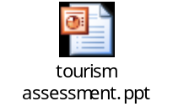  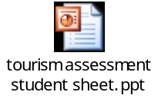  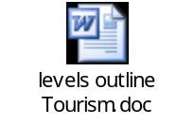 | Page 2 of the tourism sheet has a report outline that can be given out to SEN students. |  |  | Homework – to work on the assessment.

